FreeETarget
FreeETarget Youth Program

FreeETarget is an open source project to make Electronic Scoring Systems (ESS) accessible to youth shooting clubs worldwide. With over 1000 targets world wide from Missouri to Norway and beyond, FreeETarget offers sporting clubs the opportunity to train on world class equipment at a fraction of the cost of commercial equipment.

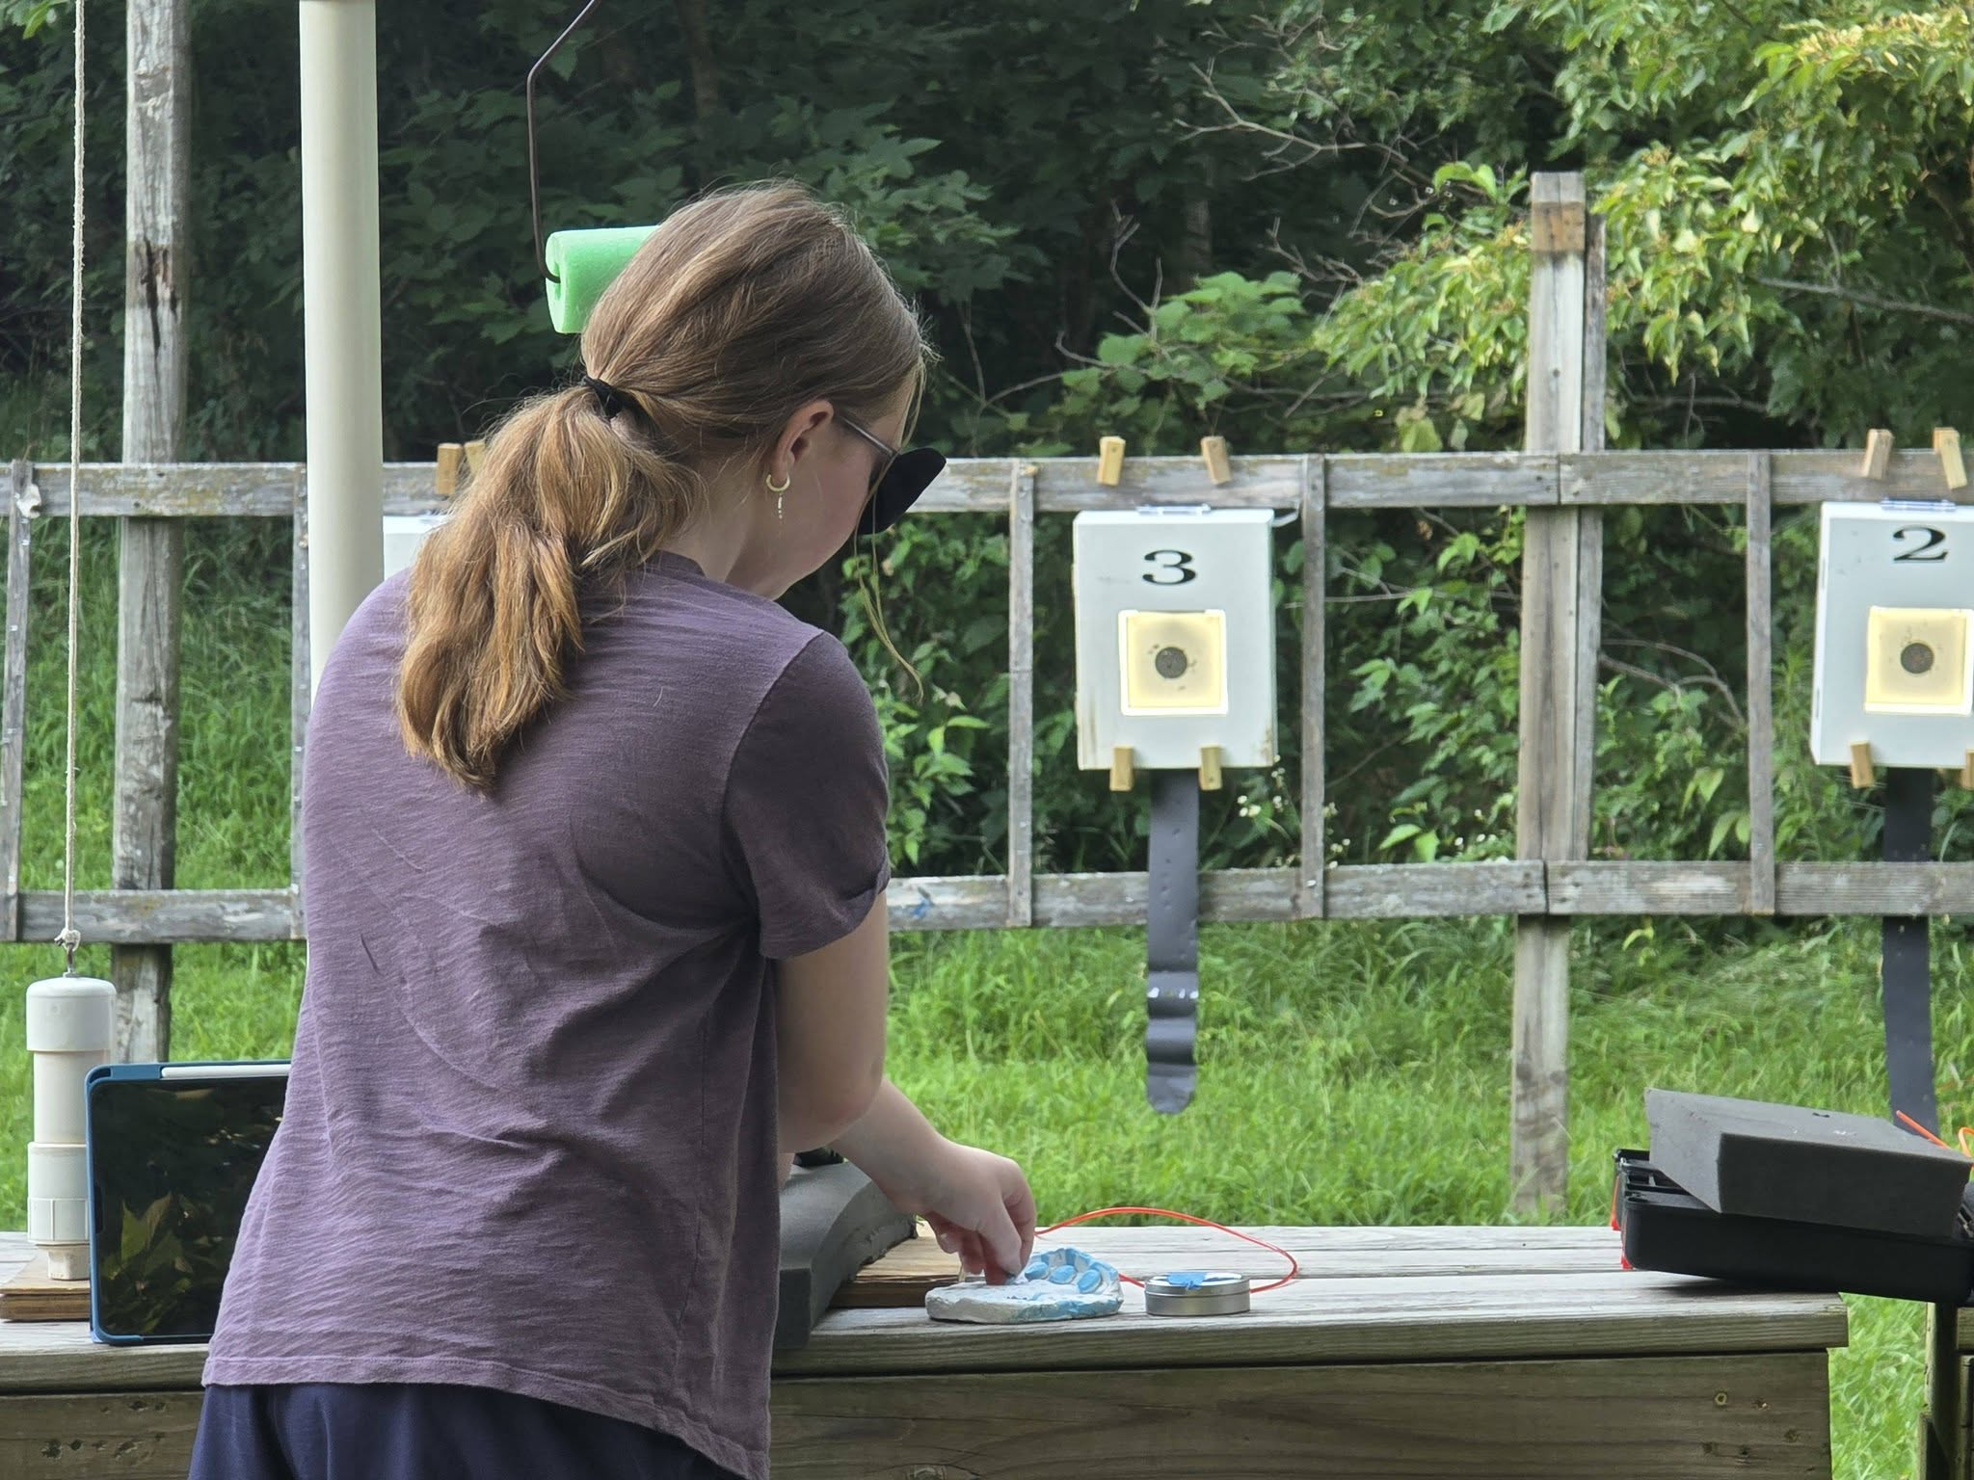
(photo courtesy of … 4H club in … Missouri)

Youth clubs start by assembling the target from a kit or locally sourced materials. Once the target is ready, it can be used for training in a variety of disciplines.
- Training sequences to improve shot discipline
- STEM projects in construction and software development

